|  |
| --- |
| **3.1 Class Work** |

**“Let’s Get Physical or Chemical”**

*Choose whether the following is an example of a physical property or chemical property*

*and explain why.*

|  |  |  |
| --- | --- | --- |
| **Description** | **Property (Physical or Chemical? If physical, intensive or extensive?** | **Why?** |
| **Apple is red** |  |  |
| **Helium is a gas** |  |  |
| **Iron (Fe) reacts with water to form rust** |  |  |
| **Silver (Ag) reacts with moisture in the air to form tarnish.** |  |  |
| **Gold is malleable and has luster.** |  |  |
| **Wood is flammable.** |  |  |

|  |
| --- |
| **3.1 Class Work** |

**SAMPLE QUESTIONS**

|  |  |
| --- | --- |
| **Question** | **Key Words/Explain Answer** |
| Which of the following would be examples of a chemical property?   1. Most metals will react with acids. 2. Water can be a solid, liquid, or a gas. 3. Water mixes well with ethanol. | KEY WORDS AND SYMBOLS:  EXPLANATION:  ________________________________________________  ________________________________________________  ________________________________________________  ________________________________________________ |
| Which of the following is an intensive property of a box of crackers?  A. Calories per serving.  B. Total grams.  C. Total number of crackers.  D. Total calories. | KEY WORDS AND SYMBOLS:  EXPLANATION:  ________________________________________________  ________________________________________________  ________________________________________________  ________________________________________________ |
| Which of the following is an extensive property?  A. The color of charcoal is black.  B. Gold is shiny.   C. The volume of orange juice is 25 mL. | KEY WORDS AND SYMBOLS:  EXPLANATION:  ________________________________________________  ________________________________________________  ________________________________________________  ________________________________________________ |
| Which of these is a chemical property?  (a) Oxygen is a gas at 25°C.  (b) Helium is very nonreactive.  (c) Ice melts at 0°C.  (d) Sodium is a soft, shiny metal. | KEY WORDS AND SYMBOLS:  EXPLANATION:  ________________________________________________  ________________________________________________  ________________________________________________  ________________________________________________ |

|  |
| --- |
| **3.1 Class Work** |

|  |  |
| --- | --- |
| **Question** | **Key Words/Explain Answer** |
| Which is a chemical property of water?   |  |  | | --- | --- | | a. | It freezes. | | b. | It decomposes. | | c. | It evaporates. | | d. | It boils. | | KEY WORDS AND SYMBOLS:  EXPLANATION:  ________________________________________________  ________________________________________________  ________________________________________________  ________________________________________________ |
| An example of a physical property of an element is the element’s ability to   |  |  | | --- | --- | | a. | react with an acid | | b. | react with oxygen | | c. | form a compound with chlorine | | d. | form an aqueous solution | | KEY WORDS AND SYMBOLS:  EXPLANATION:  ________________________________________________  ________________________________________________  ________________________________________________  ________________________________________________ |
| Which statement describes a chemical property of bromine?   |  |  | | --- | --- | | a. | Bromine is soluble in water. | | b. | Bromine has a reddish-brown color. | | c. | Bromine combines with aluminum to produce AlBr3. | | d. | Bromine changes from a liquid to a gas at 332 K and 1 atm. | | KEY WORDS AND SYMBOLS:  EXPLANATION:  ________________________________________________  ________________________________________________  ________________________________________________  ________________________________________________ |
| Which statement describes a chemical property of iron?   |  |  | | --- | --- | | a. | Iron can be flattened into sheets. | | b. | Iron conducts electricity and heat. | | c. | Iron combines with oxygen to form rust. | | d. | Iron can be drawn into a wire. | | KEY WORDS AND SYMBOLS:  EXPLANATION:  ________________________________________________  ________________________________________________  ________________________________________________  ________________________________________________ |

|  |
| --- |
| **3.1 Class Work** |

|  |  |
| --- | --- |
| **Question** | **Explanation of Answer** |
| 1. Which statement describes a chemical property of the element magnesium? 2. Magnesium is malleable. 3. Magnesium conducts electricity. 4. Magnesium reacts with an acid. 5. Magnesium has a high boiling point. | KEY WORDS AND SYMBOLS:  EXPLANATION:  ________________________________________________  ________________________________________________  ________________________________________________  ________________________________________________ |
| 1. Which statement describes a chemical property of oxygen? 2. Oxygen has a melting point of 55 K. 3. Oxygen can combine with a metal to produce a compound. 4. Oxygen gas is slightly soluble in water. 5. Oxygen gas can be compressed. | KEY WORDS AND SYMBOLS:  EXPLANATION:  ________________________________________________  ________________________________________________  ________________________________________________  ________________________________________________ |
| 1. Which statement describes a chemical property of hydrogen gas? 2. Hydrogen gas burns in air. 3. Hydrogen gas is colorless. 4. Hydrogen gas has a density of 0.00009 g/cm3 at STP. 5. Hydrogen gas has a boiling point of 20. K at standard pressure. | KEY WORDS AND SYMBOLS:  EXPLANATION:  ________________________________________________  ________________________________________________  ________________________________________________  ________________________________________________ |
| 1. An example of a physical property is the element’s ability to 2. react with an acid 3. react with oxygen 4. form a compound with chlorine 5. form an aqueous solution | KEY WORDS AND SYMBOLS:  EXPLANATION:  ________________________________________________  ________________________________________________  ________________________________________________ |

|  |
| --- |
| **3.2 Class Work** |

**Directions:** For each element, write down their location on the periodic table by group and period and then classify them as metal, metalloid, or non-metal.

|  |  |  |  |
| --- | --- | --- | --- |
| **Element** | **Group** | **Period** | **Metal, metalloid, nonmetal** |
| Silicon |  |  |  |
| Selenium |  |  |  |
| Na |  |  |  |
| Barium |  |  |  |
| I |  |  |  |
| Mg |  |  |  |
| Po |  |  |  |
| Cr |  |  |  |
| Scandium |  |  |  |
| Lead |  |  |  |
| Ge |  |  |  |
| Rb |  |  |  |
| Francium |  |  |  |
| N |  |  |  |
| Hydrogen |  |  |  |
| He |  |  |  |
| Te |  |  |  |
| Iron |  |  |  |
| Br |  |  |  |
| At |  |  |  |

|  |
| --- |
| **3.2 Class Work** |

Answer the following questions

|  |  |  |  |  |  |  |  |  |  |
| --- | --- | --- | --- | --- | --- | --- | --- | --- | --- |
| Which elements are malleable and good conductors of electricity?   |  |  | | --- | --- | | a. | iodine and silver | | b. | iodine and xenon | | c. | tin and silver | | d. | tin and xenon | | KEY WORDS AND SYMBOLS:  EXPLANATION:  ________________________________________________  ________________________________________________  ________________________________________________ |
| Most of the elements in the Periodic Table are classified as   * 1. Metalloids (3) Nonmetals   2. Noble gases (4) Metals | KEY WORDS AND SYMBOLS:  EXPLANATION:  ________________________________________________  ________________________________________________  ________________________________________________ |
| Phosphorus is best classified as a   * 1. Nonmetal (3) Metalloid   2. Metal (4) Transition element | KEY WORDS AND SYMBOLS:  EXPLANATION:  ________________________________________________  ________________________________________________  ________________________________________________ |
| Which list of elements contains a metal, a metalloid, and a nonmetal?   1. Zn, Ga, Ge (3) Si, Ge, Sn 2. Cd, Sb, I (4) F, Cl, Br | KEY WORDS AND SYMBOLS:  EXPLANATION:  ________________________________________________  ________________________________________________  ________________________________________________ |
| Which element has both metallic and nonmetallic properties?   1. Rb (3) Rn 2. Si (4) Sr | KEY WORDS AND SYMBOLS: |

|  |
| --- |
| **3.3 Class Work** |

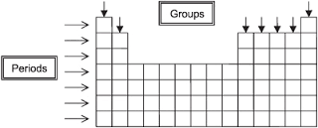

**Horizontal Rows (Left🡪Right) = __________________________________**

Looking at Period 2:

|  |  |  |  |  |  |  |  |  |
| --- | --- | --- | --- | --- | --- | --- | --- | --- |
| **Symbol of element** | Li | Be | B | C | N | O | F | Ne |
| **# of valence** |  |  |  |  |  |  |  |  |

What do you notice about number of valence electrons? _______________________________________

**Vertical Columns (Up-Down) = _________________________________ OR ________________________**

Looking at Group 17:

|  |  |  |  |  |  |
| --- | --- | --- | --- | --- | --- |
| **Symbol of element** | F | Cl | Br | I | At |
| **# of valence** |  |  |  |  |  |

What do you notice about number of valence electrons? _______________________________________

What do you notice about principal energy levels? ______________________________________

|  |
| --- |
| **3.3 Class Work** |

**Searching the Periodic Table**

1. List the atomic numbers of the elements in Period 4:
2. Write the symbols of these elements:
3. Name the lightest element in Period 4.
4. Name the heaviest element in Period 4.
5. To which group does each of these elements belong?
6. Lithium: _________________ e) nitrogen: ________________
7. Beryllium: _______________ f) oxygen: _________________
8. Boron: __________________ g) fluorine: ________________
9. Carbon: _________________ h) neon: ___________________

7) Find calcium on the Periodic Table.

1. What is the atomic number of calcium? ___________
2. To which period does calcium belong? ____________
3. To which group does calcium belong? ____________
4. Name the elements that have many properties like Ca. ____________________________________________________________________________________
5. Which of these elements you listed is the lightest? ___________________________
6. Which of these elements you listed is the heaviest? ___________________________

Which member of group 13 is found in the second period?

(1) Be (2) Mg (3) B (4) Al

Elements on the modern periodic table are arranged in order of increasing

1. Atomic mass (2) Atomic number
2. Number of neutrons (4) Number of valence electrons

In which group of the periodic table is oxygen located?

1. 1 (2) 2 (3) 16 (4) 17

Which element is in Group 2 and Period 7 of the Periodic Table?

|  |  |
| --- | --- |
| (a) | Magnesium (b) Manganese |
| (c) | Radium (d) Radon |

|  |
| --- |
| **3.5 Class Work** |

**How does atomic radius change ACROSS A PERIOD?**

1. Using *Table S* record the atomic radius for the elements of atomic numbers 11 through 17 from Period 3 of the Periodic Table in the chart below.

|  |  |
| --- | --- |
| **Atomic Number** | **Atomic Radius** |
| 11 |  |
| 12 |  |
| 13 |  |
| 14 |  |
| 15 |  |
| 16 |  |
| 17 |  |

1. On the grid below, mark an appropriate scale on the axis labeled “Atomic Radius.” Then plot the points from the table above on the grid. Circle and connect the points.



|  |
| --- |
| **3.5 Class Work** |

**How does the atomic radius change as we go DOWN A GROUP?**

1. Using *Table S* record the atomic radius for the elements of Group 1 listed in the chart below.

|  |  |  |
| --- | --- | --- |
| **Element** | **Atomic Number** | **Atomic Radius** |
| Lithium | 3 |  |
| Sodium | 11 |  |
| Potassium | 19 |  |
| Rubidium | 37 |  |
| Cesium | 55 |  |

1. On the grid below, mark an appropriate scale on the axis below labeled “Atomic Radius.” Then plot the points from the table above on the grid. Circle and connect the points.



|  |
| --- |
| **3.5 Class Work** |

|  |  |
| --- | --- |
| **Question** | **Key Words/Explain Answer** |
| Which of the following has the largest atomic radius?   1. Li 2. C 3. O 4. Ne | KEY WORDS AND SYMBOLS:  EXPLANATION:  ________________________________________________  ________________________________________________  ________________________________________________ |
| Which list of elements from Group 2 on the Periodic Table is arranged in order of increasing atomic radius?  A) Be, Mg, Ca B) Ca, Mg, Be  C) Ba, Ra, Sr D) Sr, Ra, Ba | KEY WORDS AND SYMBOLS:  EXPLANATION:  ________________________________________________  ________________________________________________  ________________________________________________  ________________________________________________ |
| The data table below shows elements Xx, Yy, and Zz from the same group on the Periodic Table.   |  |  |  | | --- | --- | --- | | **Element** | **Atomic Mass**  (atomic mass unit) | **Atomic Radius** (pm) | | Xx | 69.7 | 141 | | Yy | 114.8 | ? | | Zz | 204.4 | 171 |   What is the most likely atomic radius of element Yy?   1. 103 pm 2. 127 pm 3. 166 pm 4. 185 pm | KEY WORDS AND SYMBOLS:  EXPLANATION:  ________________________________________________  ________________________________________________  ________________________________________________  ________________________________________________ |
| As atomic number increases within Group 15 on the Periodic Table, atomic radius  A) decreases, only  B) increases, only  C) decreases, then increases  D) increases, then decreases | KEY WORDS AND SYMBOLS:  EXPLANATION:  ________________________________________________  ________________________________________________  ________________________________________________  ________________________________________________ |
| **3.6 Class Work** | |

**How does ionization energy change as we move ACROSS A PERIOD?**

1. Using *Table S* record the first ionization energies for the elements listed in the following chart.

|  |  |
| --- | --- |
| **Atomic Number** | **First Ionization Energy (kJ/mol)** |
| 11 |  |
| 12 |  |
| 13 |  |
| 14 |  |
| 15 |  |
| 16 |  |
| 17 |  |

1. On the grid below, mark an appropriate scale on the axis labeled “First Ionization Energy.” Then plot the points from the table above on the grid. Circle and connect the points.



|  |
| --- |
| **3.6 Class Work** |

**How does first ionization energy change as we move DOWN A GROUP?**

1. Using *Table S* record the first ionization energies for the elements listed in the following chart.

|  |  |  |
| --- | --- | --- |
| **Element** | **Atomic Number** | **First Ionization Energy (kJ/mol)** |
| He | 2 |  |
| Ne | 10 |  |
| Ar | 18 |  |
| Kr | 36 |  |
| Xe | 54 |  |

1. On the grid below, mark an appropriate scale on the axis labeled “First Ionization Energy.” Then plot the points from the table above on the grid. Circle and connect the points.



|  |
| --- |
| **3.6 Class Work** |

|  |  |
| --- | --- |
| Which element requires the least amount of energy to remove the most loosely held electron from a gaseous atom in the ground state?  A) bromine B) calcium  C) sodium D) silver | KEY WORDS AND SYMBOLS:  EXPLANATION:  ________________________________________________  ________________________________________________  ________________________________________________  ________________________________________________  ________________________________________________ |
| As the elements of Group 1 on the Periodic Table are considered in order of increasing atomic radius, the ionization energy of each successive element generally  A) decreases  B) increases  C) remains the same | KEY WORDS AND SYMBOLS:  EXPLANATION:  ________________________________________________  ________________________________________________  ________________________________________________  ________________________________________________  ________________________________________________ |
|  | |

|  |
| --- |
| **3.6 Class Work** |

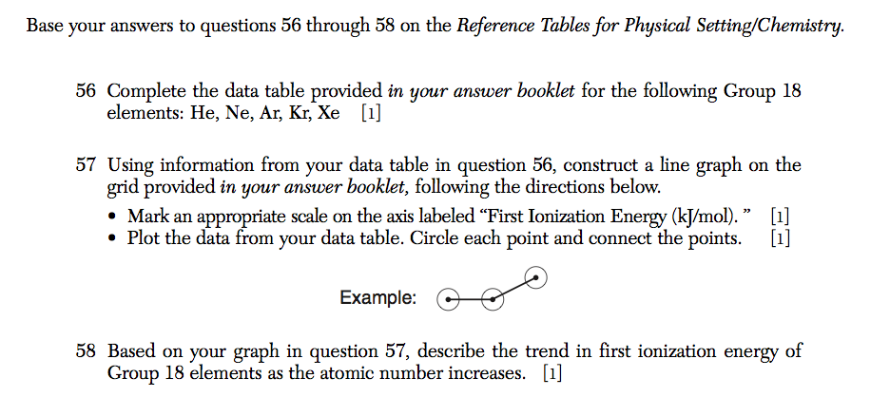

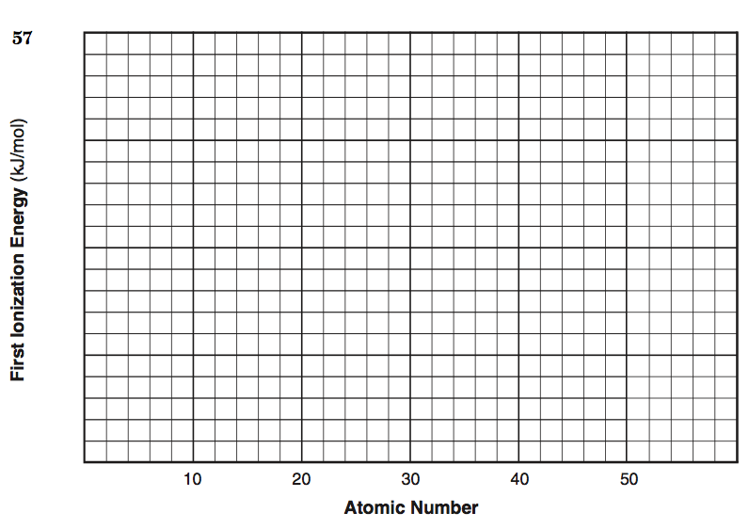

|  |
| --- |
| **3.7 Class Work** |

**How does ELECTRONEGATIVTY change as we move ACROSS A PERIOD?**

1. Using *Table S* record the electronegativity for the elements listed in the following chart.

|  |  |
| --- | --- |
| **Atomic Number** | **Electronegativity** |
| 11 |  |
| 12 |  |
| 13 |  |
| 14 |  |
| 15 |  |
| 16 |  |
| 17 |  |

1. On the grid below, mark an appropriate scale on the axis labeled “Electronegativity.” Then plot the points from the table above on the grid. Circle and connect the points.



|  |
| --- |
| **3.7 Class Work** |

**How does ELECTRONEGATIVITY change as we move DOWN A GROUP?**

1. Using *Table S* record the electronegativity for the elements listed in the following chart.

|  |  |  |
| --- | --- | --- |
| **Element** | **Atomic Number** | **Electronegativity** |
| F | 9 |  |
| Cl | 17 |  |
| Br | 35 |  |
| I | 53 |  |

1. On the grid below, mark an appropriate scale on the axis labeled “Electronegativity.” Then plot the points from the table above on the grid. Circle and connect the points.



|  |
| --- |
| **3.7 Class Work** |

|  |  |
| --- | --- |
| The strength of an atom’s attraction for the electrons in a chemical bond is the atom’s  A) electronegativity B) ionization energy  C) heat of reaction D) heat of formation | KEY WORDS AND SYMBOLS:  EXPLANATION:  ________________________________________________  ________________________________________________  ________________________________________________  ________________________________________________  ________________________________________________ |
| An atom of which element has the greatest attraction for electrons in a chemical bond?  A) As B) Ga C) Ge D) Se | KEY WORDS AND SYMBOLS:  EXPLANATION:  ________________________________________________  ________________________________________________  ________________________________________________  _______________________________________________ |
| Which general trend is demonstrated by the Group 17 elements as they are considered in order from top to bottom on the Periodic Table?  A) a decrease in atomic radius  B) a decrease in electronegativity  C) an increase in first ionization energy  D)an increase in valence electrons | KEY WORDS AND SYMBOLS:  EXPLANATION:  ________________________________________________  ________________________________________________  ________________________________________________  ________________________________________________ |
| Which statement describes the general trends in electronegativity and metallic properties as the elements in Period 2 are considered in order of increasing atomic number?  A) Both electronegativity and metallic properties decrease.  B) Both electronegativity and metallic properties increase.  C) Electronegativity decreases and metallic properties increase.  D) Electronegativity increases and metallic properties decrease. | KEY WORDS AND SYMBOLS:  EXPLANATION:  ________________________________________________  ________________________________________________  ________________________________________________  ________________________________________________  ________________________________________________ |
| **3.7 Class Work** | |

