Interactive Notebook Guidelines
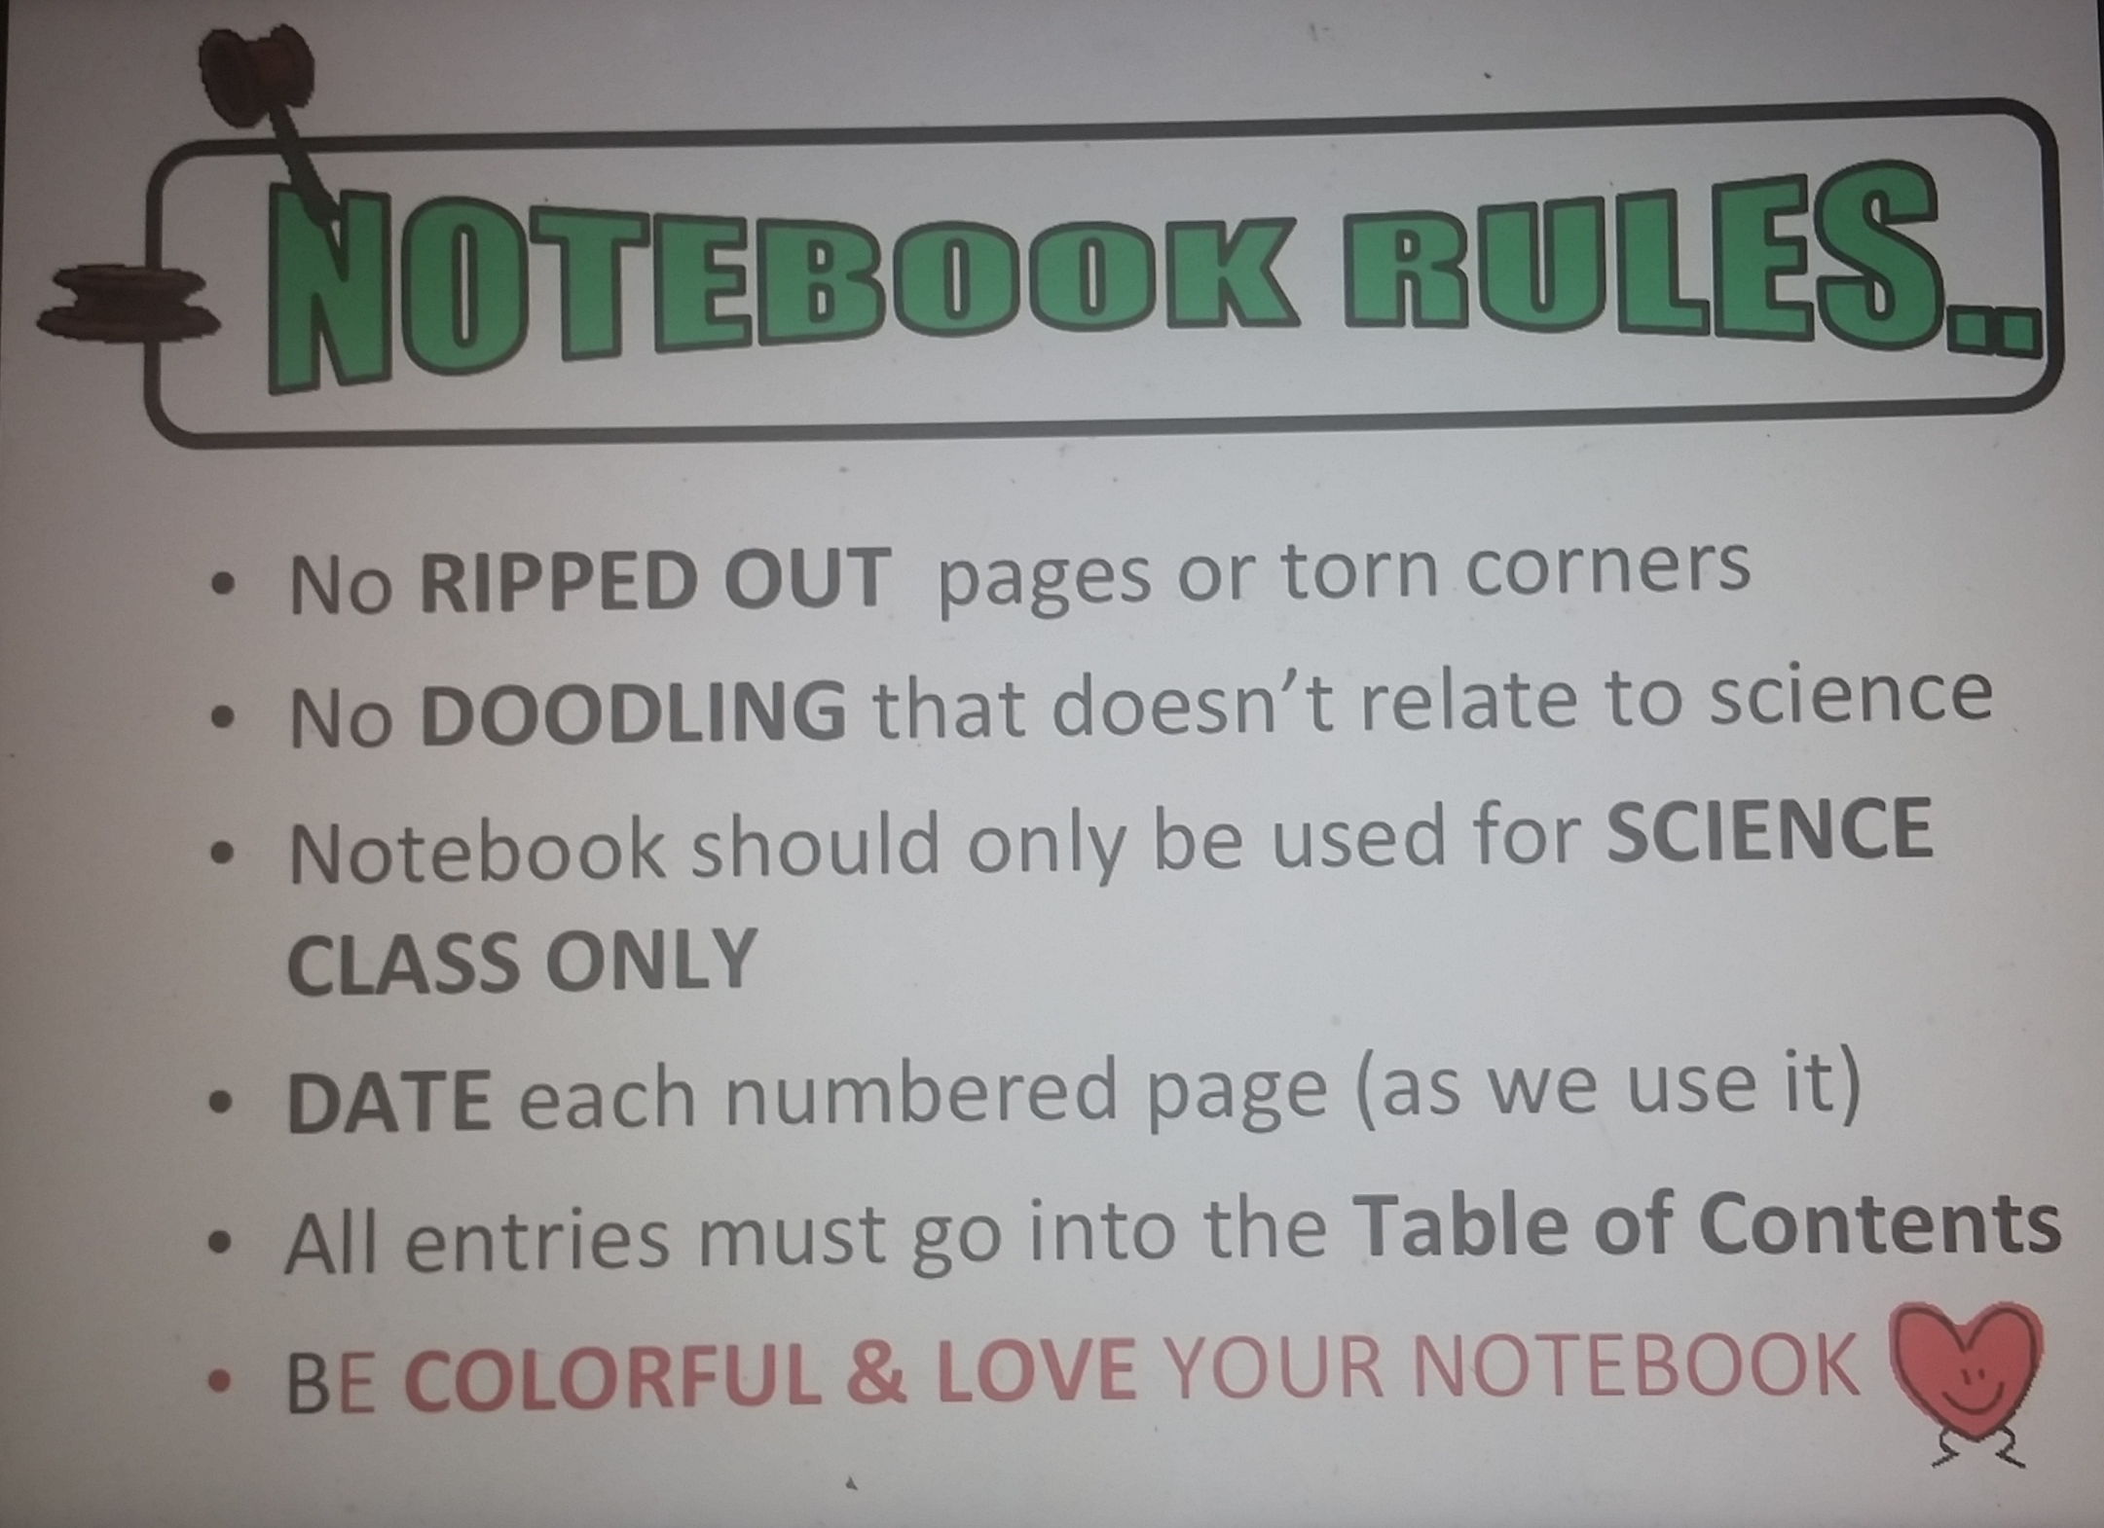

- Use the front AND back of each page. I deduct points for blank pages.
- ☺ Handouts: Neatness counts... A LOT.
- ☺ Fold oversized handouts so they don’t hang over the edge of the notebook.
- ☺ Develop the habit of adding titles and dates to ALL assignments.

Tips for Success:
- ☺ Bring your notebook with you EVERY SINGLE DAY.
- ☺ Keep your table of contents updated! It’s VERY easy to fall behind.
- ☺ Complete your assignments when they are given. Pulling all‐nighters to do all the work the night before the due date is NOT fun.
- ☺ If you are not sure how to do something, ASK for help!

